# Name - Aman Maurya

# Roll No. - 223CS3153

# Course - M. Tech (Year-I)

# Branch - CSE (Software Engineering)

# Assignment - (4) JUnit & PyUnit

# Rectangle Test:

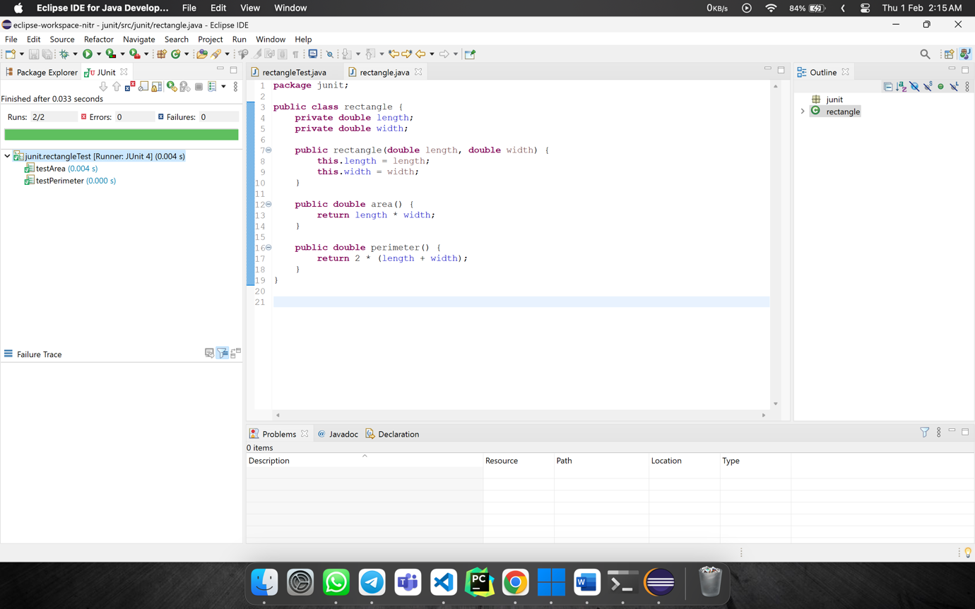

JUNIT

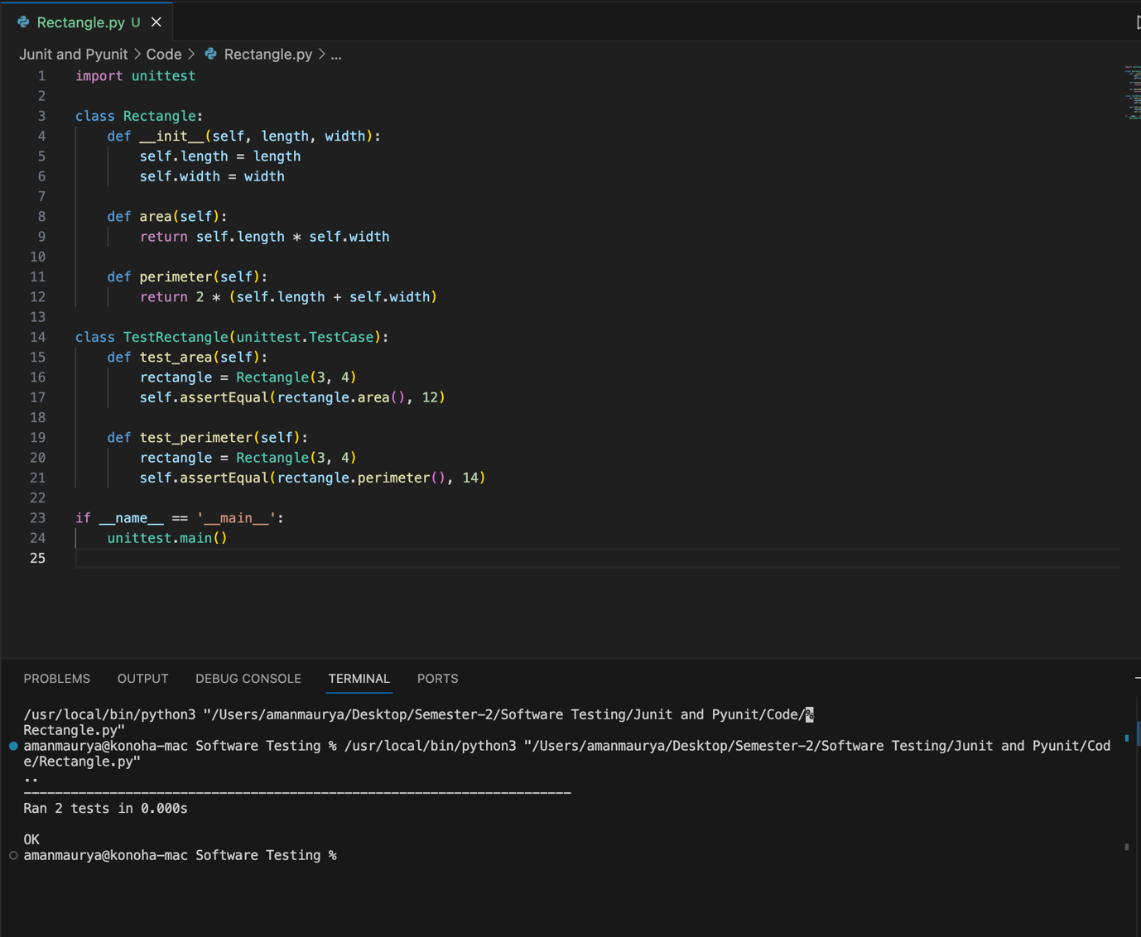

PYUNIT

# String Operations

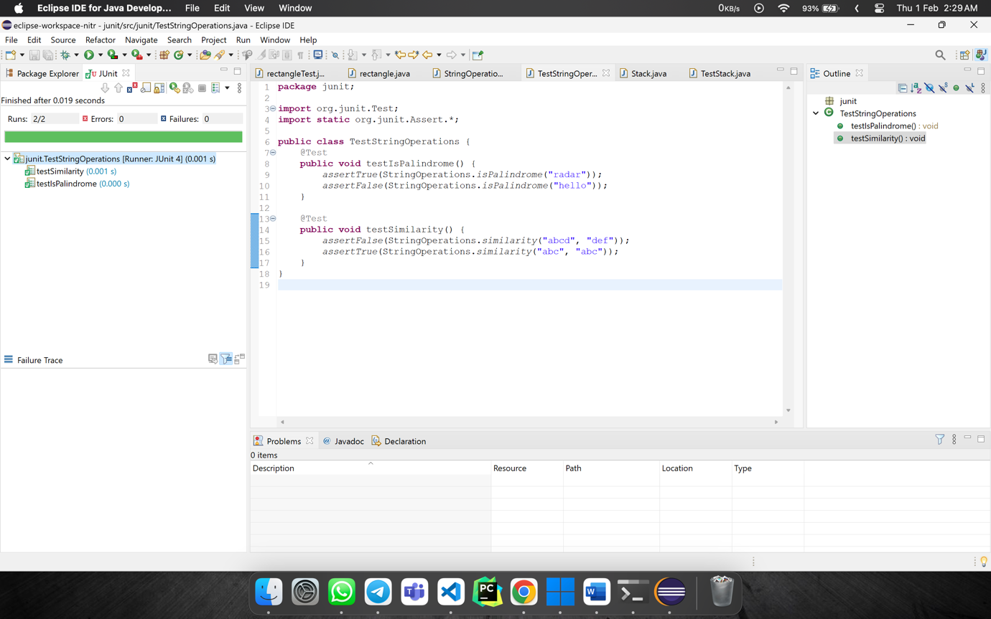

JUNIT

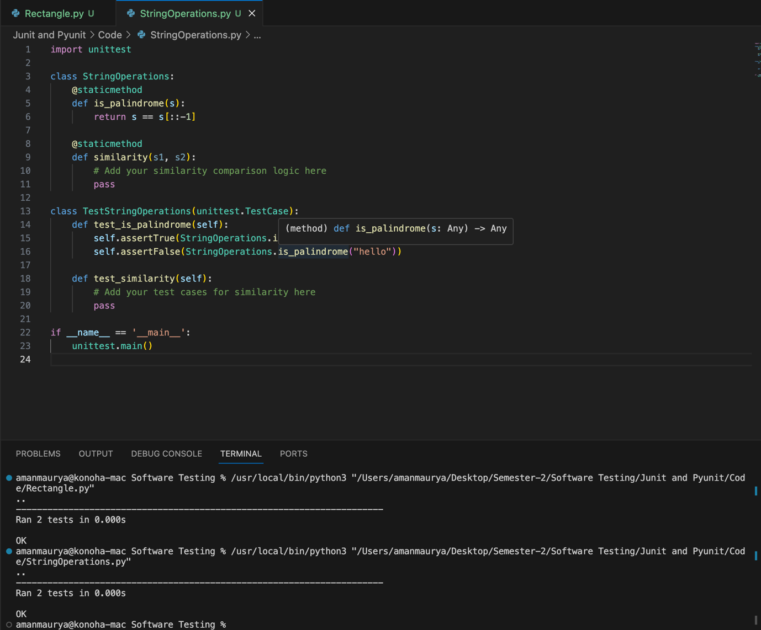

PYUNIT

# Constructor Classes

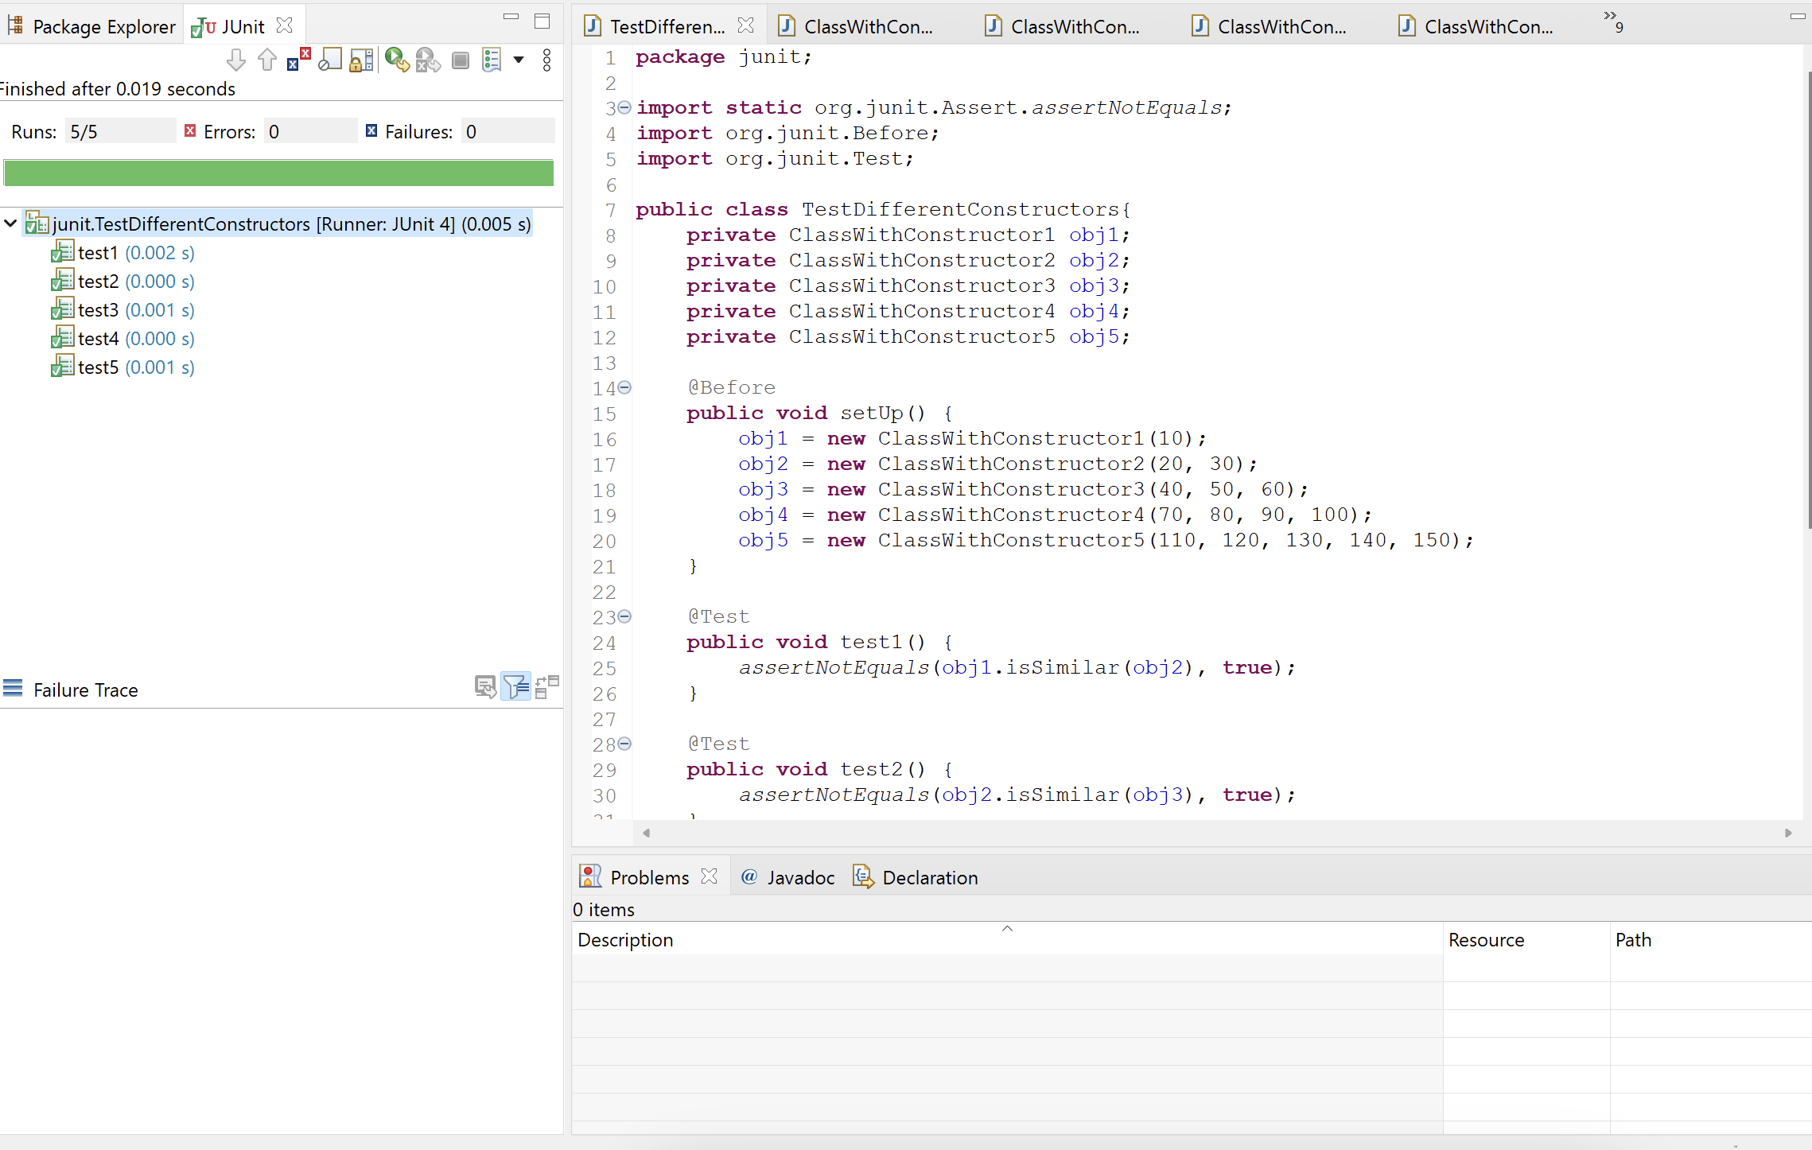

JUNIT

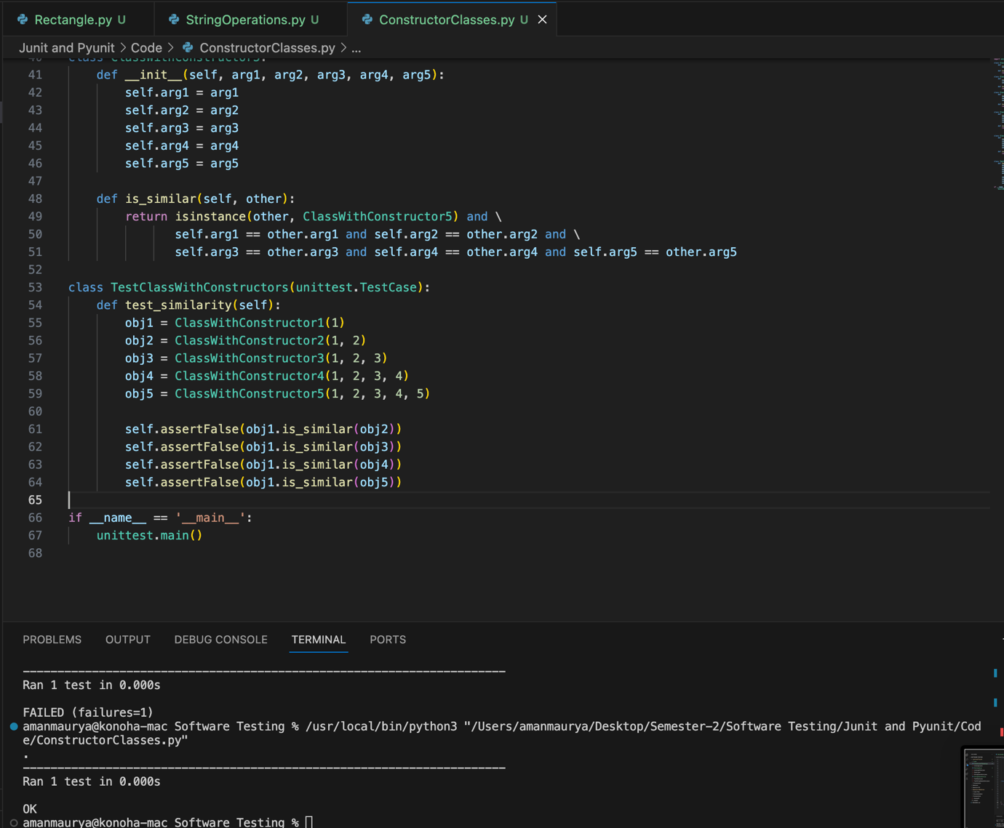

PYUNIT

# List Test

JUNIT

PYUNIT

# Stack Test

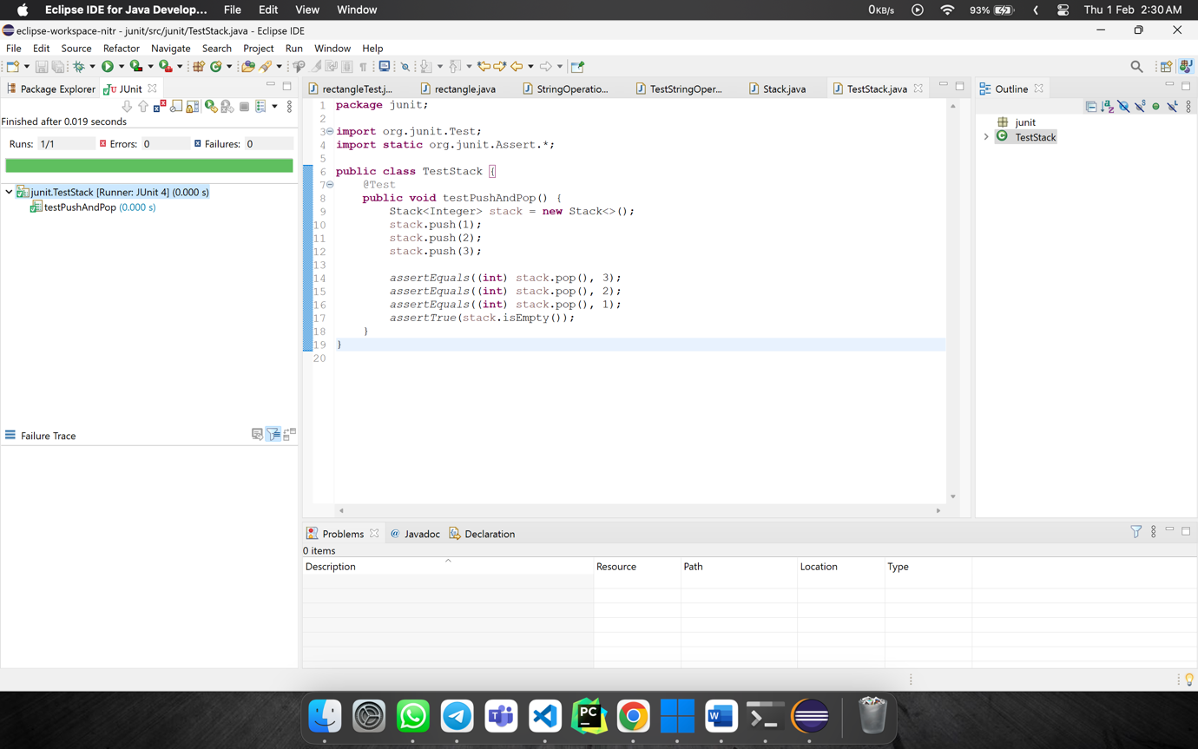

JUNIT

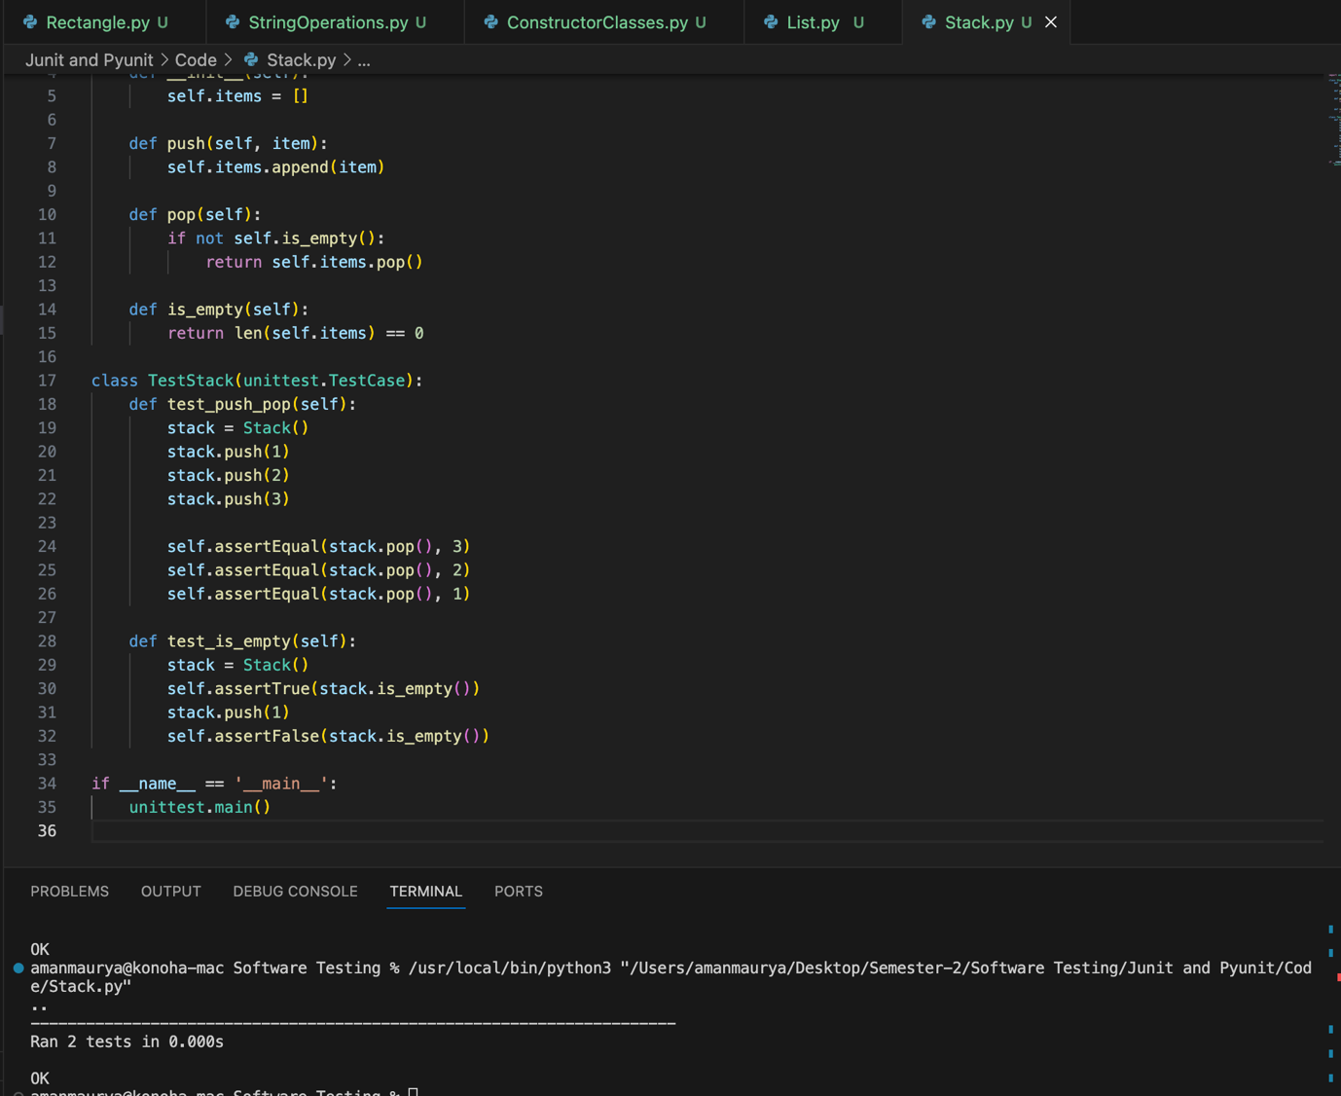

PYUNIT